----------------------------------------------------------------------------------------------------------------
NAME: VISHAL.V
REG.NO: 192419033
COURSE CODE: ECA0404
COURSE NAME: ANALOG CIRCUITS
PRACTICAL LAB RESULTS
----------------------------------------------------------------------------------------------------------------
EXP-8(LT spice experiment)
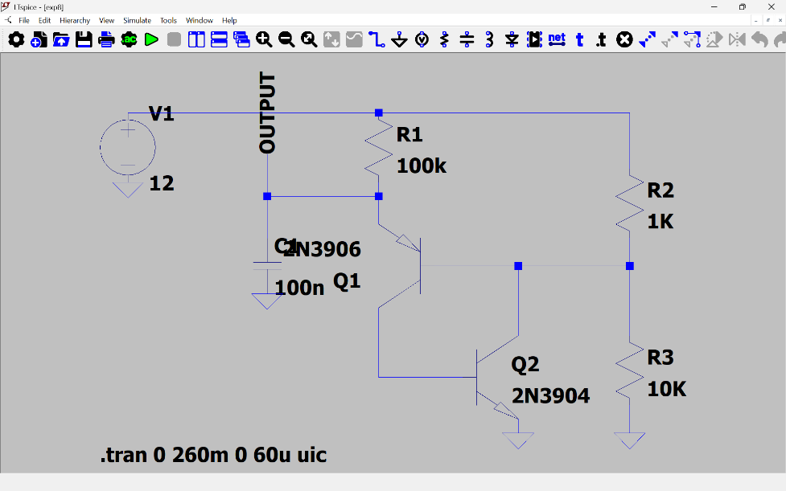
CIRCIUT DIAGRAM:

PROCEDURE:
1. Draw UJT oscillator in LTSpice.
2. Configure RC network.
3. Run transient analysis.
4. Observe sawtooth waveform.
5. Measure oscillation frequency.
PROCEDURE:
1. Connections are made as shown in the circuit diagram.
2. The DC power supply is switched ON.
3. The output waveform is displayed on the CRO.
4. The peak-to-peak Amplitude and time period of the sine wave is noted.
5. The graph of output waveform is drawn.
PROCEDURE:
1.Connections are made as shown in the circuit diagram.
2. The DC power supply is switched ON.
3. The output waveform is displayed on the CRO.
4. The peak-to-peak Amplitude and time period of the sine wave is noted.
5. The graph of output waveform is drawn

OUTPUT(GRAPH): -

